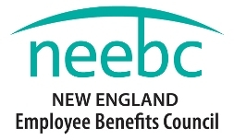
NEEBC 35th Anniversary Celebration Gala: The Pops Play the Beatles
Thursday, May 14, 2105
Registration Form
Name _____________________________________________________________________
Title _______________________________________________________________________
Company___________________________________________________________________
Address____________________________________________________________________
State______________________ Zip________________________________
Email ______________________________________________________________________

Number of tickets @ $135 each ______________
Number of tables (5 seats per table) @ $675 each ________________
Payment:
Type of Charge ( ) Master Card ( ) Visa ( ) American Express

Name on card: __________________________________________________________________________

Billing address on card: ___________________________________________________________________
Zip: ___________________

Card Number: __________________________________Exp. Date: ____________ Security code: ________

I will send a check _________________ Please send me an invoice________________
Make all checks payable to New England Employee Benefits Council. Payment is due within 30 days.
NEEBC 240 Bear Hill Road Suite 102 Waltham, MA 02451. Phone: 781-684-8700. Fax: 781-684-9200
Please email, fax, or mail this form to Sue Seltzer: sue@neebc.org

We expect this event will sell out quickly - please reply early. Seating is assigned on a first come, first-served basis. Requests for shared tables must be received at the same time. Due to POPS deadlines no tickets will be sold after 4-1.
Tickets will be at the registration table the day of the event.

