**Annual Best Practices Conference Sponsorship Opportunities**



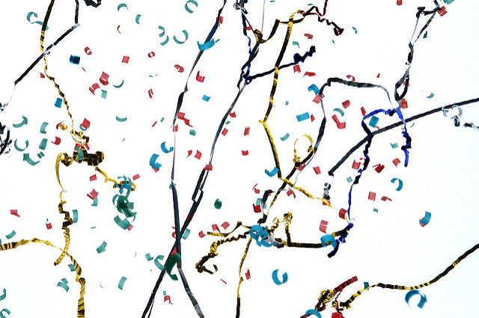

Tuesday, December 11, 2018 at The Westin Waltham Hotel

Introduce your brand to NEEBC’s passionate benefits professionals! Our Best Practices Conference – **now celebrating 20 years** - is energy packed and focused on innovation… which means folks attending are open to new ideas! Registration form follows. Questions? Call or email me for details:

Linda Viens, NEEBC

781-684-8700 * linda@neebc.org

|  |  |  |  |  |  |  |
| --- | --- | --- | --- | --- | --- | --- |
| Sponsor Benefits | Premier (limited to 1) | ~~Reception~~  (SOLD!) | ~~Luncheon~~  (SOLD!) | ~~Breakfast~~  (SOLD!) | ~~Exhibit~~  (SOLD OUT!) | Spotlight |
| Clapping HandsProminent Recognition as Premier Sponsor including all attendee lanyards | Premier Sponsor Logo on Lanyards |  |  |  |  |  |
| MicrophoneWelcome Audience – Opportunity to comment on the power of innovation and legacy of Best Practices | Exclusive:  Kick-Off Event | Exclusive:  Cocktail Reception | Luncheon | Breakfast |  |  |
| HandshakeExhibitor Table at Event – build your brand and network face-to-face with current & potential clients | Premier Location (includes 1 rep) | Premier Location (includes 1 rep) |  |  | Standard |  |
| ListPrinted Materials – Insert materials for attendee Conference Resource Kit | ● | ● | ● | ● | ● | ● |
| Projector screenProfessional Signage – Large signs at registration, conference, & exhibitor area | Prominent Throughout | Reception Logo plus Reception Table Tents | Luncheon Logo plus Lunch Table Tents | Breakfast Logo plus Bkfast Table Tents | Listed | Listed |
| NewspaperWinter NEEBC Newsletter – Thank you with logo alongside conference highlights | Thank You & Logo | Thank You & Logo | Thank you & Logo | Thank You | Thank You | Thank You |
| MegaphoneRecognition in Social Media | 2 Months | 1 Month | 1 Month | 1 Month | 1 Month | 1 Month |
| Credit cardEvent registration | 2 people | 1 person | 1 person | 1 person | 1 person  (table rep) | 1 reduced  registration ($125) |
| NetworkWebsite Recognition | Premier Logo/Link | Reception Logo/Link | Luncheon Logo/Link | Breakfast Logo/Link | Name/Link | Name/Link |
| INVESTMENT | $5,000 | $2,500 | $2,000 | $1,500 | $1,250 | $1,000 |



.2565

Annual Best Practices Sponsor Registration Form

**Don’t miss the opportunity to be part of our 20th Annual Best Practices Conference**

**Tuesday, December 11, 2018 at The Westin Waltham Hotel**

Name: ____________________________________________ Company: _________________________________________________________

Address: ____________________________________________________________________________________________________________

Phone: Email: ______________________________________________________________________

□ Premier ($5,000) ~~□ Reception ($2,500)~~ ~~□ Luncheon ($2,000)~~ ~~□ Breakfast ($1,500)~~ ~~ □ Exhibit ($1,250)~~  □ Spotlight ($1,000)

Check payable to: **NEEBC** (enclosed) or via charge:

Card No: _______________________________ Exp Date: ________________ Security Code: ________ Type: Visa MasterCard Am Ex

Zip code: ___________________ Name on card: _______________________________ Signature: ___________________________________



**Return form or reach out with questions:**

Linda S. Viens, NEEBC



Manager of Operations and Member Services

1. Virginia Road, Suite 217, Concord, MA  01742

781-684-8700 * linda@neebc.org

*You can fax form to: 781.684.9200*